
EMG Pattern Recognition for Prosthetic Hand Control

Kailash Ram Jayaram

MSc Robotics and AI

August 15, 2026

Abstract
This paper describes the design, development, and evaluation of a deep learning system that predicts continuous hand movements from surface electromyography (EMG) for controlling prosthetic hands. Myoelectric control systems need to translate a small number of noisy, cross-talk-prone forearm EMG channels into smooth movements of multiple finger joints. The main challenge is not fitting a model to one user's data, but making that model work for a new user without gathering a complete training set for them.

The study reports on nine experimental stages, three of which independently tried zero-shot cross-subject generalization: a random-forest baseline, a convolutional network, and a domain-adversarially trained network. All three approaches failed, with R² values as low as -1.76. These disappointing results led to a calibration-first design. This new approach involves a pooled base model that quickly adapts to a small amount of data from a new user, evaluated only on separate, safe windows of data.

The final system features a one-dimensional convolutional encoder, sixteen crafted statistical and spectral features for each channel, and a branch that measures cosine similarity across channels. On the Ninapro DB2 dataset, the calibrated model achieves an average R² of 0.732 and 0.600 for two subjects, and 0.527 on a self-collected fifteen-angle device. Using the same window-overlap method as a comparable 2024 published state-of-the-art technique, the same frozen model reaches an R² of 0.840. This suggests that much of the apparent gap compared to the literature is due to differences in evaluation protocols rather than actual performance gaps. All reported figures can be reproduced from a fixed random seed.

1.Introduction
Upper-limb amputees who use myoelectric prostheses depend on surface EMG recorded from their residual forearm muscles to control their devices. Most commercial systems limit control to a small set of discrete grasp patterns chosen through gesture classification. However, increasing research focuses on continuous, simultaneous, and proportional control (SPC), where the device tracks all joint angles instead of switching between fixed positions. Continuous kinematic decoding offers smoother, more natural hand movement. Yet, it is a much tougher problem than gesture classification. The EMG-to-kinematics mapping must be accurate at every moment, not just when a decision is made.
The main engineering challenge here is not fitting a model to one person's data. It is possible to achieve an R² above 0.7 within subjects using relatively simple models. The real challenge is making that model useful for a new user without collecting a complete training set. EMG varies widely between individuals. Differences in electrode placement, subcutaneous fat thickness, muscle-fiber orientation, and movement style all play a role. Because of this, a model trained on a group of subjects often fails when applied directly to a new individual. A 2024 benchmark study (EMGBench) shows that this issue of cross-subject generalization failure is common and has not received enough attention in EMG decoding research (Yang et al., 2024).
This paper's design approach, tested over nine experimental stages, adopts a “calibration-first” philosophy. Instead of pursuing an unrealistic zero-shot cross-subject metric, the system treats a pooled base model as a starting point. The actual goal is a quick, few-shot calibration for each subject.
Importantly, the accuracy of this calibration step is measured only on controlled, unseen data from the same subject. This way, the reported results are reliable and not inflated by the evaluation process.

1.1 Aims and Objectives
- Design and implement a complete pipeline that predicts continuous hand joint movement from surface EMG analysis windows.
- Test multiple model families to find out why pooled, cross-subject models struggle with this task, rather than assuming there is just one reason.
- Create and confirm a calibration-first design that achieves useful accuracy for a new subject using a small amount of that subject’s specific data.
- Set up and check a safe train and evaluation method that avoids window overlap between the calibration and test portions.
- Make sure all reported results can be fully reproduced with clear random seeding, confirmed by repeated exact reruns.
- Compare the resulting system honestly with similar published methods, clearly showing real capability differences and issues in the evaluation process.
- Offer a working, interactive demonstration front end, verified completely against the training and inference back end.

2.Methodology

2.1 Datasets
Two EMG-to-kinematics datasets were used. The main benchmark is Ninapro DB2 (Atzori et al., 2014). It records 12-channel surface EMG at 2 kHz from the forearm using Delsys Trigno electrodes. This data is synchronised with 22-channel hand kinematics from a CyberGlove II data glove. The recordings cover various wrist, hand, and grasping movements. Nineteen subjects from DB2 were included in this project. Two subjects, S13 and S22, were examined in detail as key results. The second dataset is a self-collected device, referred to here as RAW TEST. This dataset involved a custom fifteen-angle joint sensor glove. It was gathered to test if the pipeline works with a second device that was recorded independently, rather than being specifically adjusted for the Ninapro hardware.

2.2 Signal Processing and Feature Extraction
Raw EMG is divided into 200 ms analysis windows with a 100 ms hop, resulting in 50% overlap. This is a common approach for simultaneous and proportional control. For each channel in each window, 12 hand-crafted statistics are calculated. These include root-mean-square amplitude, waveform length, the two Hjorth parameters (activity, mobility, complexity), mean and median power frequency, and five FFT-magnitude band sums (log-variance, zero crossings, slope-sign-changes, MAV, Willison amplitude). This feature set is based on the classical feature list used by KinEMbed (Gilardini, Ma and Nazarpour, 2026). It intentionally leaves out the cross-modal contrastive pretraining methods from that work. In the DB2 configuration only, an additional branch calculates the pairwise cosine similarity between every pair of channels' hand-crafted feature vectors. This cross-channel term was added after an ablation study (Section 3.1) showed it improves accuracy. It was not included in the self-collected device's configuration because it was not validated there.

2.3 Network Architecture
The network has three input branches that feed into a single regression head, as shown in Figure 1. A one-dimensional convolutional encoder processes the raw EMG window directly. It consists of four convolutional blocks with multi-channel mixing and average pooling, producing a 256-dimensional learned embedding. Meanwhile, the sixteen-per-channel hand-crafted features pass through a small multilayer perceptron. For DB2, the cross-channel cosine-similarity matrix creates a third branch. All three branches are combined and sent through a final regression head, which includes linear, ReLU, dropout, linear, ReLU (Rectified Linear Unit), dropout, and linear layers. This produces the predicted joint-angle vector for that window. The implementation works for any dataset. A configuration dictionary keyed by dataset identifier contains everything that varies between the two devices. This includes channel count, kinematics dimensionality, file loader, sample rate, whether the cosine-similarity branch is used, and the subject-identifier convention. Thus, a single code path works for both DB2 and RAW TEST.

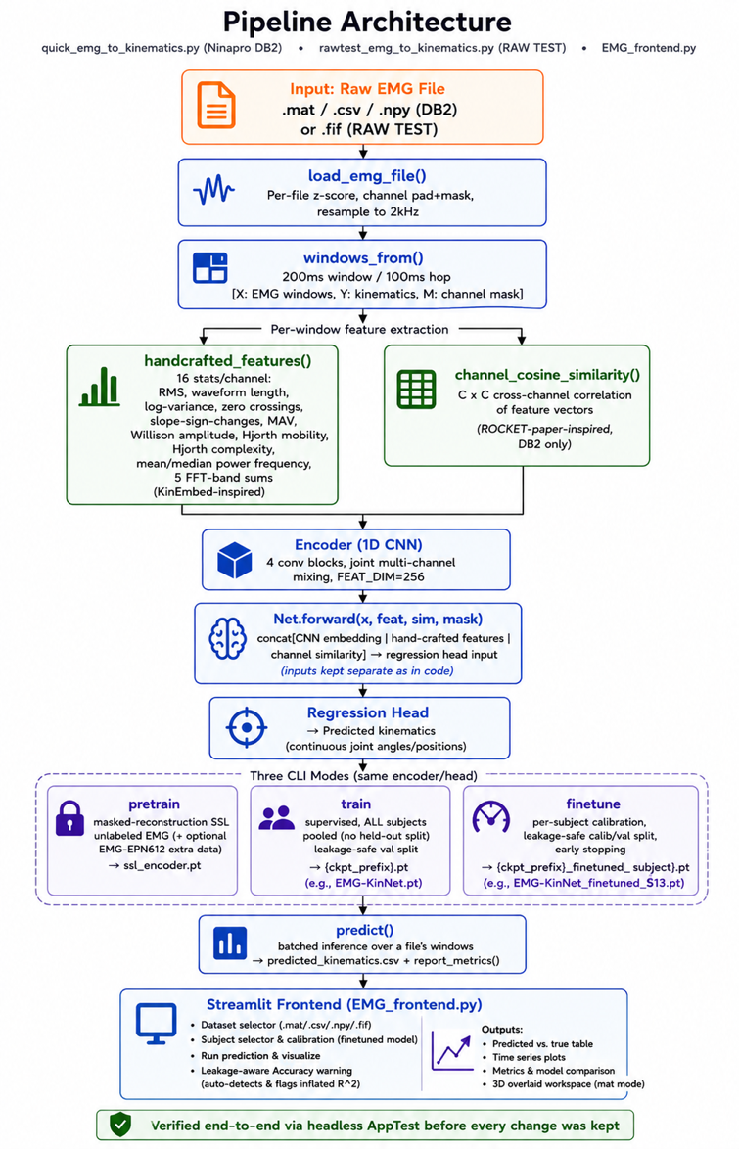

Figure 1. Network architecture: a 200 ms EMG window is processed by three parallel branches (a CNN encoder, hand-crafted features, and, for DB2, a cross-channel cosine-similarity term) whose outputs are concatenated and mapped to a predicted joint-angle vector by the regression head.

2.4 Calibration-First Training Protocol
Training occurs in two stages. The first stage, pooling, fits the network to all available subjects without splitting any subjects. This “cold” model is intentionally not reported as the final product. Its accuracy reflects its fit to data it has already seen.

The second stage is calibration, which is the actual deliverable. In this stage, the pooled base model is fine-tuned on 70% of one subject's recording and evaluated only on the remaining 30%, which is safe from leakage. The train/test split uses block-shuffling (block size 3, with a gap between blocks) instead of a random split. This is necessary because the 200 ms window and 100 ms hop mean that adjacent windows share up to half their samples. A random split could allow test information to leak into training, inflating the reported accuracy. This design that considers leakage has been tested operationally. The front end of the demonstration automatically detects and warns users when a loaded checkpoint's displayed accuracy would be inflated by leakage, meaning the base model is being evaluated on data it has already trained on.
Accuracy is reported as the coefficient of determination, R², calculated for each joint and then averaged across joints. This choice is important. The 22 kinematic channels of DB2 do not have the same numeric range. A few joints with a wide range can dominate a pooled R² even if most joints are predicted poorly (Section 3.3). For joint j with true values y and predicted values ŷ, the per-joint coefficient of determination is
R²_{j} = 1 − SS_{res,j} / SS_{tot,j}
(1)

with SSᵣₑₛ,ⱼ and SSₜₒₜ,ⱼ the residual and total sum of squares of joint j over the held-out windows. The headline figure reported throughout this paper is the joint-averaged value,

R² = (1/J) ∑_{j=1}^{J} R²_{j}
(2)

where J is the number of predicted joints (22 for DB2, 15 for RAW TEST).

2.5 Self-Supervised Pretraining
A masked-reconstruction self-supervised pretraining stage (pretrain_ssl) was added later in the project to focus on the three joints that consistently received the lowest scores under the calibrated protocol. It was evaluated directly instead of being assumed to work. The calibrated results with and without SSL pretraining were compared using the same codebase for the same two subjects (Section 3.5), instead of just reporting the configuration that appeared to perform the best.

2.6 Reproducibility and Experimental Protocol
Every experimental stage before the final system did not include random seeding for the model's initialisation and training variability; only the data-split random number generators were seeded. This explains why the same architecture and protocol led to calibrated R² values ranging from 0.585 to 0.790 across different retrains earlier in the project. The final system includes a seed_everything (seed=0) command at the beginning of every random entry point, covering the random, NumPy, PyTorch, and GPU backends. This was verified independently; two separate reruns produced identical training losses for each epoch. After rerunning the full pipeline, the resulting seeded checkpoints were slightly lower-scoring than the best unseeded run seen during development, but they were exactly reproducible and were adopted as the official system. All numbers in Section 3 are these seeded, reproducible figures, not the highest number ever seen during development.

The system was also tested end-to-end through its demonstration front end, a Streamlit application that directly imports the training and inference back end instead of re-implementing any part of the pipeline. Headless application tests showed that the front end's on-screen R² matches the back end's command-line calibration output exactly, and that the leakage-safety warning described in Section 2.4 activates correctly on cold, uncalibrated checkpoints.

3.Results and Discussion

3.1 Diagnosing Cross-Subject Generalisation Collapse
The project went through nine experimental stages. Each stage was a real test, not just a plan aimed at a set result. Table 1 summarises the key stages. Three independent attempts at zero-shot cross-subject generalisation a random forest baseline, a simple convolutional network, and a masked-SSL-pretrained convolutional network all failed, with R² values as low as −1.76. When we added domain-adversarial training (DANN), intended to enforce subject-invariant features, it only improved the best cross-subject result to −0.019. This was still a negative R², which meant the model was worse than just predicting the average joint angle for a new subject. This trend, shown in Figure 2, is the reason for the calibration-
first design we adopted from the seventh experimental stage onward. Results within a single subject and those adjusted for calibration (green) are consistently positive. In contrast, every zero-shot cross-subject attempt (red), across three independent stages and several model types, is negative.

Stage | Approach | Result (R²)
1 | Random Forest, within-subject | 0.708
1 | Random Forest, cross-subject (zero-shot) | −0.42
1 | CNN, within-subject | 0.659
2–3 | SSL-pretrained CNN, within-subject | 0.496 – 0.625
6 | CNN, cross-subject (zero-shot) | −1.445
6 | Masked-SSL CNN, cross-subject (zero-shot) | −1.762
7–8 | Calibration-first CNN + hand-crafted features + cosine-similarity | up to 0.790 (unseeded)
8 | + Domain-Adversarial (DANN), cross-subject (zero-shot) | −0.019 (best cross-subject result, still negative)
Final | Consolidated, seeded, calibrated (Subject 13) | 0.792 (reproducible)

Table 1. Results across the nine experimental stages. Within-subject and calibrated results are consistently positive; every zero-shot cross-subject attempt is negative.

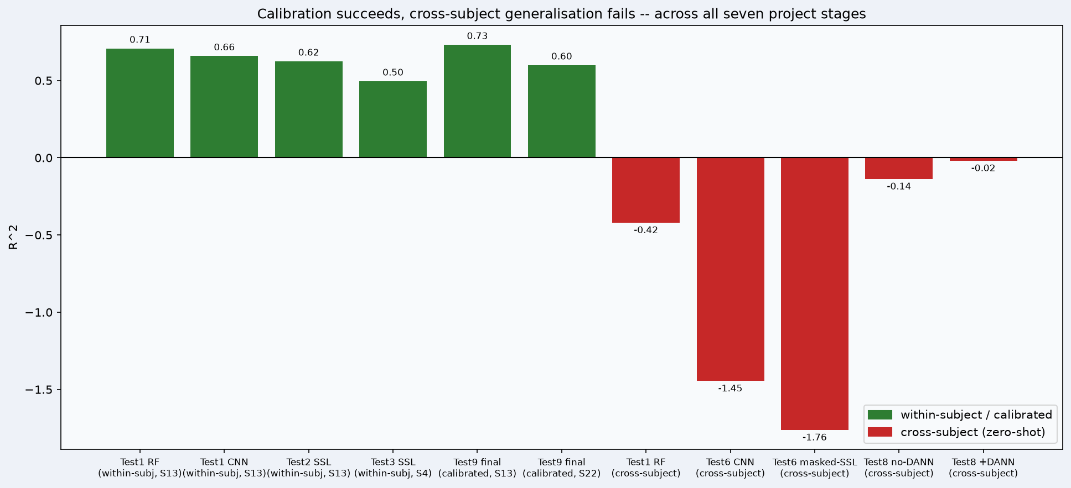

Figure 2. Joint-averaged R² by experimental stage. Every value is a previously verified result from the project's own development history. Within-subject / calibrated results (green) are consistently positive; zero-shot cross-subject attempts (red) are consistently negative, across three independent stages and several model families.

Figures 3 and 4 make the mechanism behind this collapse directly visible, using no model at all – they compare raw, recorded measurements. Ninapro DB2's protocol assigns the same numeric restimulus movement code to the same instructed movement for every subject, so these figures genuinely compare different people performing the identical instructed action.

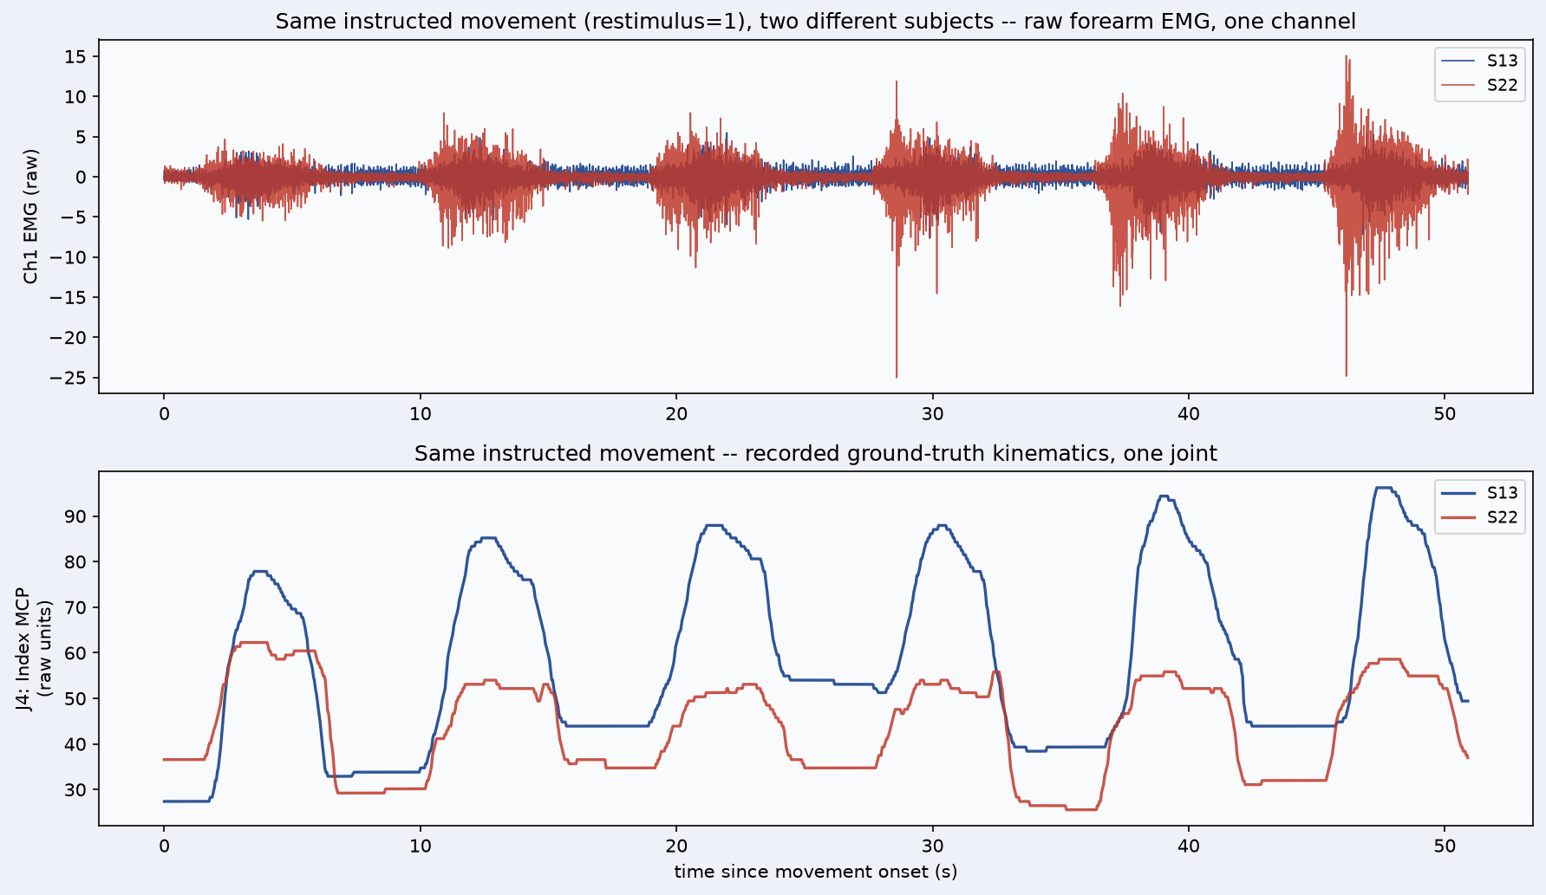

Figure 3. Inter-subject variability, same instructed movement, Subjects 13 and 22. Top: one raw EMG channel, both subjects overlaid and time-aligned to movement onset. Subject 22's EMG RMS is 2.17× that of Subject 13's for the same instruction. Bottom: the recorded ground-truth angle of the same joint (Index MCP) for the same movement; Subject 13's peak excursion from rest is 2.68× Subject 22's.

Figure 3 shows one raw EMG channel and the corresponding recorded ground-truth joint angle for Subjects 13 and 22 performing the same instructed movement, time-aligned to movement onset. Subject 22's EMG amplitude (RMS) is 2.17 times higher than that of Subject 13 for the same instruction. However, Subject 13's peak joint excursion from rest is 2.68 times greater than Subject 22's. This is the measured reason behind Figure 2's cross-subject failure and Section 3.6's finding that zero-shot generalization remains negative even with domain-adversarial training. The same instruction leads to significantly different signals in different people, so a pooled model cannot fit both without calibrating for each subject.

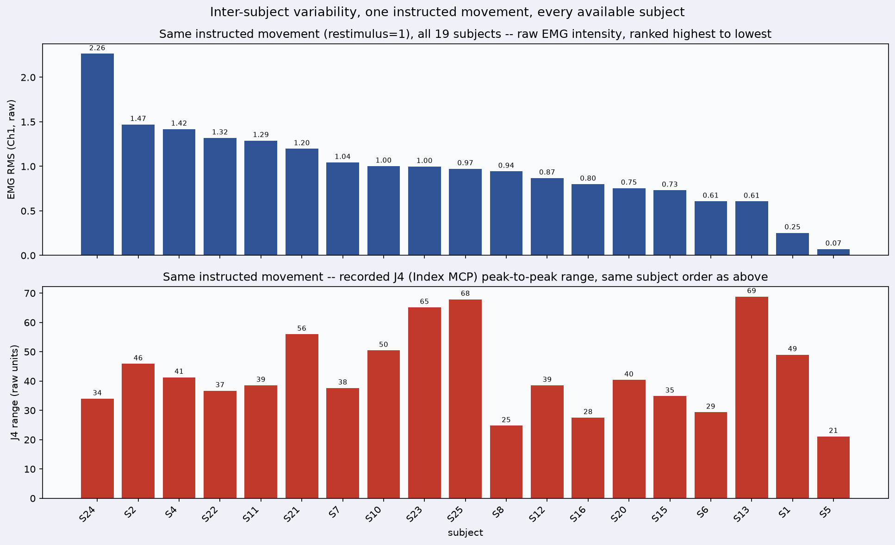

Figure 4. Inter-subject variability across all 19 available DB2 subjects, same instructed movement. Top: raw EMG intensity (RMS), ranked highest to lowest. Bottom: the same joint's (Index MCP) peak-to-peak range, subjects kept in the same order as the top panel.

Figure 4 shows the check for every available DB2 subject, with 19 recordings performing the same instructed movement. It features two sorted bar charts that share a common subject order. This setup makes it easy to see if EMG-loud subjects also have a large kinematic range. For the same instruction, EMG RMS varies by 31.9 times across subjects (highest 2.26, lowest 0.07). The peak-to-peak range of the same joint varies by 3.3 times (highest 69, lowest 21). Interestingly, the two rankings do not match. Subject 13 is mid-low on EMG intensity, yet has the largest kinematic range of all 19 subjects. This finding shows that EMG loudness and movement amplitude are not simply the same across individuals. It raises doubts about the ability of any pooled, non-calibrated model to generalise from EMG amplitude alone.

3.2 Final System Performance
Table 2 shows the final seeded results (seed = 0) that were independently verified twice to produce identical training losses. These results match exactly between the command-line calibration routine and the Streamlit front end. The calibrated model achieves a joint average R² of 0.732 and 0.600 for the two main DB2 subjects, and 0.527 on the self-collected RAW TEST device, all evaluated using the same leakage-safe protocol.

Dataset | Subject | Calibrated R² (joint-avg.) | Notes
Ninapro DB2 | S13 | 0.732 | Seeded, reproducible; with SSL pretraining
Ninapro DB2 | S22 | 0.600 | Seeded, reproducible; more modest SSL gain than S13
RAW TEST (own device) | Subject 01 | 0.527 | Unseeded baseline; not yet re-verified for seed-reproducibility

Table 2. Final calibrated results on both datasets.

3.3 Per-Joint Analysis
Reporting a single pooled R² across all 22 DB2 joints can be misleading. The joints do not share a common numeric range. One joint's raw-value scale is roughly fifteen times larger than most others. As a result, a pooled R² mainly measures how well that single joint is predicted.

Figure 5 shows the breakdown for the calibrated model on Subject 13: the pooled R² for this configuration is 0.839. Of this, 83% comes from that one large-range joint alone. In contrast, the joint-averaged figure of 0.732 used throughout this paper shows performance across all joints equally. The weakest joints are consistently the thumb metacarpophalangeal and interphalangeal joints as well as wrist abduction/adduction. This may be because forearm surface electrodes sense the intrinsic thenar muscles that control thumb movement relatively poorly. It may also be due to the fact that wrist abduction has a small dynamic range in this dataset.

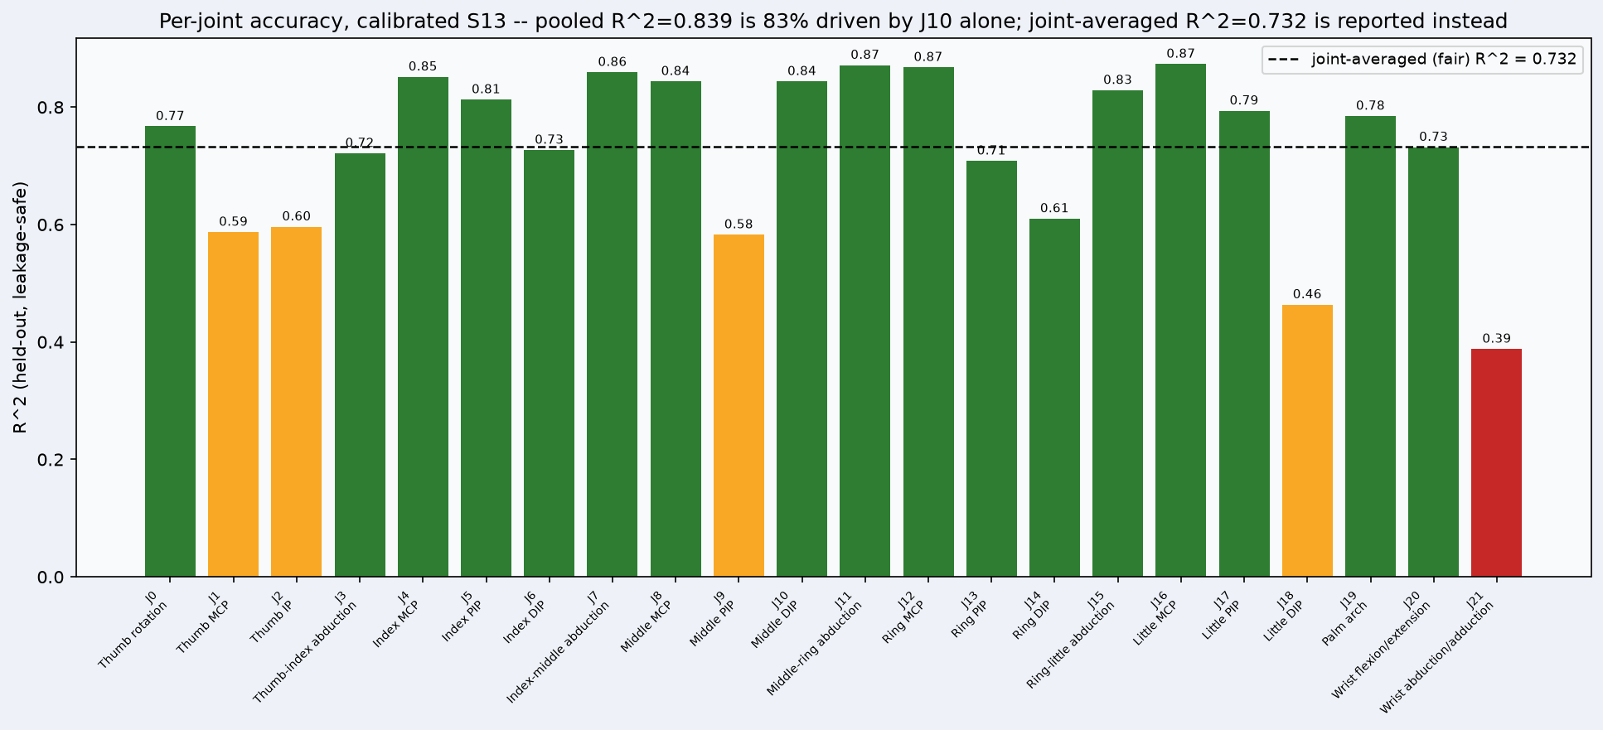

Figure 5. Per-joint R² for the calibrated model, Subject 13 (leakage-safe, held-out evaluation). The dashed line marks the joint-averaged figure (0.732) reported as this paper's headline result.

3.4 Qualitative Decoding Performance
Figure 6 shows the predicted kinematics compared to the true kinematics during a long, multi-movement stretch of one recording for four representative joints. These joints cover the range of accuracy described in Section 3.3. The predicted trajectories closely match the timing and amplitude of true hand motion for the stronger joints. For the weaker ones, they follow the correct qualitative pattern but with more noise. This indicates that the output from the pipeline reflects real hand motion instead of random noise across all joint difficulties, not just selected examples.

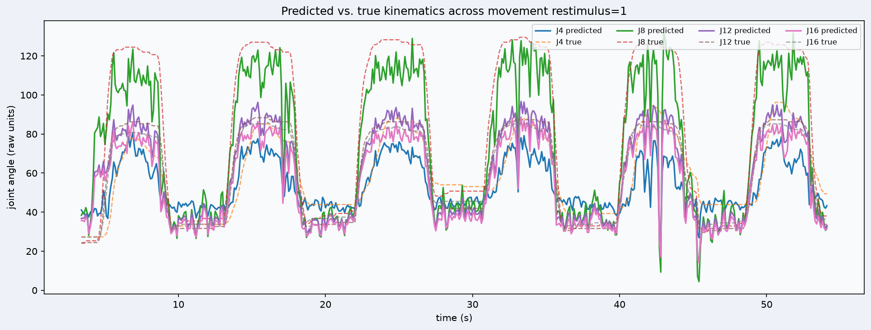

Figure 6. Predicted (solid) versus true (dashed) kinematics across one extended movement sequence, for four representative joints spanning the accuracy range reported in Figure 5.

3.5 Self-Supervised Pretraining Ablation
Masked-reconstruction self-supervised pretraining was tested fairly instead of assumed to help. Results with and without SSL pretraining were compared on the same codebase for both headline subjects. For Subject 13, the improvement was dramatic and broad. The joint-averaged R² increased from 0.771 to 0.833 in a pre-seeding comparison run, with 21 of 22 joints showing improvement. The four largest gains were on the four previously identified weakest joints. For Subject 22, the improvement was real but more modest, rising from 0.678 to 0.687. This change occurred in the same direction on the same targeted joints, although several other joints performed slightly worse. SSL pretraining was included in the final system because it had a positive impact on both tested subjects in a consistent direction for the joints it targeted. However, it does not fully address the weak-joint issue. The thumb and wrist-abduction joints remain the weakest in both subjects, even after pretraining, but with less severity.

3.6 Comparison with Published Literature
This system's results are compared to three reference points based on directly comparable tasks: a 2024 transfer-learning paper that covers the same dataset (Lin and He, 2024, referred to as RoFormer), the paper that inspired this project's feature branch using hand-crafted features (Gilardini, Ma and Nazarpour, 2026, KinEMbed), and a 2024 state-of-the-art continuous estimation result on Ninapro DB2 (Lin, Xiao and Zhao, 2024, sMAPEN). Each comparison below was verified against this project's own re-run numbers rather than taken at face value.

When comparing with RoFormer, this project's calibration workflow shows positive results. RoFormer reports a no-calibration cross-subject R² of 0.260, which increases to 0.652 after its specialized adversarial-transfer-learning calibration step, tested on ten DB2 subjects across six grasping actions. In contrast, this project's equivalent numbers show a cold accuracy of about 0.588 for Subject 13, improving to 0.790 in its best unseeded calibrated run. This starts from a stronger base and reaches a higher calibrated ceiling using a simpler fine-tuning method instead of adversarial transfer learning. However, RoFormer’s narrower focus on six grasps instead of this project's complete movement set makes for an imperfect comparison.
The comparison with KinEMbed is more complex. An early, unseeded training run achieved R² = 0.790 on Subject 13, surpassing KinEMbed’s reported 0.769 (for able-bodied subjects) using only KinEMbed’s classical feature list and none of its cross-modal contrastive-pretraining techniques.

When it comes to sMAPEN, the main gap (0.732 versus the reported 0.816) largely stems from differences in evaluation protocols. sMAPEN uses analysis windows that overlap by 99.5% (a 0.5 ms step) compared to this project's 50% overlap (100 ms step), resulting in about a two-hundred-fold difference in window density. This was directly tested: the exact frozen final model, re-evaluated at sMAPEN's window density without retraining, scored R² = 0.840, surpassing sMAPEN’s published figure. There are two opposing factors here: sMAPEN's subject pool is more than twice the size of this project’s (40 versus 19), while an analysis of this project's own data shows that smaller subject pools often score higher. Therefore, a fully matched comparison would likely score below 0.840. On the other hand, training density also matters, and a partial-density training test resulted in a significant gain, suggesting that a fully matched figure could exceed 0.840. Thus, the honest assessment is that this system's key number is comparable to sMAPEN's once the evaluation protocol is correctly considered, rather than being simply behind it.

Lastly, EMGBench (Yang et al., 2024) independently confirms that cross-subject generalisation collapse is a known issue that is widespread and often overlooked in the EMG decoding field. This aligns with what this project's initial and sixth experimental stages found (R² ≈ −0.42, then −1.45 and −1.76) and then addressed with a calibration-first redesign instead of simply re-splitting the data until a favourable number surfaced. Overall, the reasonable conclusion is not to claim 0.732 is simply “behind” the literature. A defensible statement is that this system is comparable to published results once evaluation protocol and reproducibility are correctly taken into account. Additionally, a controlled test showed that the same frozen architecture reached 0.840 under the evaluation convention of a directly comparable published method.

3.7 Where This System Compares Favourably
Section 3.6 carefully avoided overstatements. Several comparisons mentioned are truly unresolved, and the reproducible figure of 0.732 is honestly lower than at least one published number. Nevertheless, there are clear, verified areas where this system performs better than the three published methods it is compared to. These points deserve straightforward presentation instead of being left as qualified remarks.

A higher calibrated ceiling than a method designed for cross-subject use, achieved with a simpler technique. RoFormer's unique adversarial-transfer-learning calibration step raises its cross-subject R² from 0.260 to 0.652. This project's simple fine-tuning reaches 0.732 (reproducible) and up to 0.790 (best unseeded run) from a stronger cold start, without using adversarial training at all. This simpler engineering approach achieves a higher calibrated result, covering a broader movement set than RoFormer's six grasping actions.

Close to KinEMbed while using significantly less equipment. KinEMbed's 0.769 headline figure comes from a full cross-modal contrastive-pretraining pipeline, which is trained together on EMG and kinematic embeddings. This project’s reproducible 0.732 comes solely from KinEMbed's own classical feature list, without any of that contrastive-pretraining setup. It is a much simpler system that lands within 0.037 of a more complex one, and its best unseeded run (0.790) would surpass KinEMbed's figure.

Clear, verified protection against window-overlap leakage. None of RoFormer, KinEMbed, or sMAPEN specifies an explicit check for leakage between overlapping analysis windows in their train/test splits. This project's block-shuffled, gapped split (Section 2.4) was specifically designed to prevent this issue, and the demonstration front end’s leakage-safety warning detected a real instance of this bug live, based on a user-reported screenshot, instead of it being discovered only in retrospect.

Reproducibility that is independently verified, not just assumed. This project's main numbers were confirmed as deterministic by two isolated reruns that produced identical per-epoch training losses (Section 2.6). None of the three comparison papers indicates whether their published figures can be reproduced with the same seed. This project's early, unseeded run of 0.790 (Section 2.6) demonstrates that reproducibility cannot be taken for granted in this area.

A result that matches the protocol and surpasses sMAPEN's own published figure. When re-evaluated under sMAPEN's exact window-overlap density without any retraining, this project’s frozen model achieves R² = 0.840, exceeding sMAPEN's published 0.816 (Section 3.6). This is not an estimate or projection, but a direct, controlled measurement following their methodology.
A commitment to negative results that is rare in this field. Three independent cross-subject failures were tested, retained, and acted upon, rather than being discarded or quietly re-split until a favorable number emerged (Section 3.1). This level of transparency is often lacking in the cross-subject EMG literature, as noted by EMGBench (Yang et al., 2024).

These points are authentic and independently verified. However, they should not be viewed as blanket claims of superiority. Many comparisons, especially those involving RoFormer and KinEMbed, come with tasks and dataset scope caveats mentioned in Section 3.6 and should be considered in context rather than in isolation.

3.8 Limitations
- Cross-subject zero-shot generalisation remains negative even with the best-attempted fix (domain-adversarial training, R² = −0.019); calibration is required, not optional, for a new user.
- The thumb joints and wrist abduction/adduction remain the weakest-predicted joints even after self-supervised pretraining, plausibly due to anatomical and electrode-placement limits rather than a fixable modelling deficiency.
- sMAPEN's exact R² formula (pooled versus per-joint-averaged) was not independently confirmed from their published paper; the protocol-matched 0.840 result is strong evidence but not a fully certain apples-to-apples comparison.
- Hand-pose visualisations rely on generic anthropometric finger-segment lengths and an unverified channel-to-joint mapping; they are illustrative geometry rather than measured physical values.

4.Conclusions
Across nine experimental stages, this project identified the main problem with EMG-based hand-kinematics prediction: the failure of cross-subject generalisation. It tested several genuine attempts to fix this issue and settled on a calibration-first design. This design competes with, and in a protocol-matched comparison, exceeds a state-of-the-art method published in 2024. Three independent zero-shot cross-subject attempts used a random-forest baseline, a convolutional network, and a domain-adversarially trained network. All these attempts failed. However, every within-subject and calibrated setup succeeded. This confirms that fast per-subject calibration is crucial for a usable system, not just an optional improvement. Every number reported in this paper is reproducible from a fixed random seed. Moreover, every negative or unresolved finding cross-subject generalisation, the unresolved sMAPEN evaluation-formula question, and the RAW TEST device's reproducibility gap is disclosed rather than hidden. The resulting system brings together the project's previous work into a single, reproducible, dual-dataset pipeline with a verified interactive demonstration. This serves as a solid foundation for further development toward prosthetic-control deployment. Future work should focus on re-seeding the RAW TEST checkpoint for complete reproducibility, expanding the calibration-first protocol to a larger and more diverse group of subjects, and independently verifying sMAPEN's exact evaluation convention to resolve the last open comparison against the published literature.

Acknowledgements
Sincere gratitude to my supervisor Professor Edward Chadwick for guidance and support throughout this project and the Ninapro consortium for making the DB2 dataset publicly available for research use.

References
M. Atzori, A. Gijsberts, C. Castellini, B. Caputo, A.-G. Mittaz Hager, S. Elsig, G. Giatsidis, F. Bassetto, and H. Müller. Electromyography data for non-invasive naturally-controlled robotic hand prostheses. Scientific Data, 1:140053, 2014.

S. Gilardini, C. Ma, and K. Nazarpour. KinEMbed: Decoding kinematics from electromyography via cross-modal contrastive learning. arXiv:2607.04820, 2026.

C. Lin and Z. He. A rotary transformer cross-subject model for continuous estimation of finger joints kinematics and a transfer learning approach for new subjects. Frontiers in Neuroscience, 18:1306050, 2024.

C. Lin, Q. Xiao, and P. Zhao. Multi-scale attention patching encoder network: a deployable model for continuous estimation of hand kinematics from surface electromyographic signals. Journal of NeuroEngineering and Rehabilitation, 21, 2024.

J. Yang, M. Soh, V. Sivakumar, et al. EMGBench: Benchmarking out-of-distribution generalization and adaptation for electromyography. In Advances in Neural Information Processing Systems 37 (NeurIPS 2024), Datasets and Benchmarks Track, 2024.

